**Contributor: Sarah Holian**

**Gattorno, Antonio**

Born: 1904 – Havana, Cuba; Died: 1980 – Acushnet, Massachusets, USA

Cuban painter and illustrator Antonio Gattorno is recognised as one of the founding members of the Cuban *vanguardia* (avant-garde) of the late 1920s - early 1930s in Havana, a movement that sought to define a national iconography through the people and landscape of Cuba. Like many of his colleagues in Cuba, Gattorno studied painting at the San Alejandro Academy before earning a scholarship to travel to Italy, Spain, and France between 1920-27. During this period, Gattorno studied Italian classicism and works by Paul Gauguin, which he later used to formulate his own figurative style of portraying the *guajiro* (Cuban peasant) that dominated the subject matter of his work for the following decade. During the mid-1920s, he also joined the Grupo Minorista, a group of Cuban leftist critics, writers, and artists who cautioned of United States imperialist influence and promoted a Hispano-Cuban vernacular culture. Gattorno signed the group’s manifesto published in the avant-garde journal *revista de avance* (1927-30) that called for a rejection of academic art and a renewal of Cuban art. Inspired by the political work of the Mexican muralists, Gattorno also painted a number of large-scale murals (many now lost) in Havana at the Teachers’ Training College, the Capitular Room of Town Hall, and the private residence of Dr. Gustavo Gutierrez.

Upon his return from his trip to Europe, in 1927, Gattorno was honored with an exhibition at the Asociación de Pintores y Escultores where he exhibited *Mujeres Junto al Río* (*Women by the River*). This exhibition in Havana marked the beginning of his commitment to Cuban themes, including the exploration of the theme of the *guajiro* and the lush rural landscape. Typical of his Deco style from this period, *Women by the River* features three women set in a lush, tropical landscape marked by large banana leaves, traits which become a fixture in his work of the period. To underscore the racial diversity of the island, he included an Afro-Cuban woman carrying fruit in a basket on her head, while two monumental creole nudes and a modernist still-life fill the foreground of the painting.

Gattorno’s paintings calling attention to the plight of the *guajiros* in Cuba were noticed by writers from the United States John Dos Passos and Ernest Hemingway, who collected the artist’s work and wrote the text for one of his catalogues in 1935. This same year, the painter permanently moved from Cuba to New York. His images of the period focus on the Cuban peasantry and often portray the thin, gaunt character of the male *guajiro*, fleshier female figures, and the iconic *bohío* (peasant hut). His interest in these subjects culminated in his large-scale oil on canvas mural *Waiting for Coffee* (1938) for the Bacardi Corporation’s offices at the Empire State Building in New York City. The subject of the work is the *guajiro* family presented at the far right—loosely based on earlier works such as the oil painting *Quieres más café Don Nicolas*? (*Would you like more coffee, Don Nicolas?*) (1937)—along with the central figures of a boy and a goat based on his watercolor, *The White Goat* (1935), which was awarded the 1936 Watson Blair Purchase Prize by the Art Institute of Chicago. The mural also features the ubiquitous broad banana leaves and Cuban cane fields that characterize Gattorno’s landscapes in his earliest period.

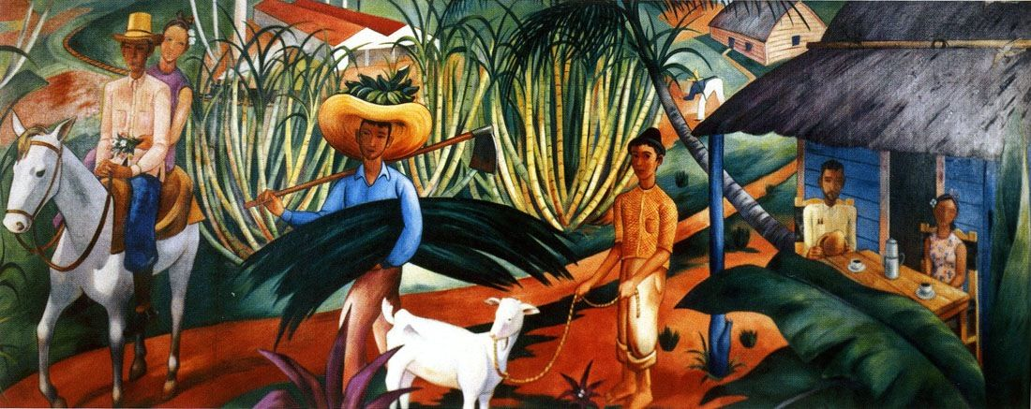

Antonio Gattorno, *Waiting for Coffee (Bacardi Mural) ,* 1938, Canvas mural, 18 x 20 ft. Displaced in 1961 to the newly constructed Bacardi Building in Miami Florida http://www.mural.ch/index.php?kat_id=w&sprache=fre&id2=2170

*Waiting for Coffee* also marks the end of the strongly Cuban national themes in his work, and Gattorno later embarked on projects he referred to as the “‘Surrealist Romanticism’ of Classical Discipline.” Many of Gattorno’s colleagues in Cuba believed that he had abandoned the obligation to address national concerns, and he found himself alienated and excluded from group exhibitions of Cuban art both in Cuba and the United States. Gattorno continued to teach art and paint until his death in 1980.

**References and futher reading:**

Dos Passos, John. “The Poor Whites of Cuba” *Esquire* (May 1936): 110.

Hemingway, Ernest (1935) *Gattorno*. Havana: Impresores Ucar García y Cía.

Mañach, Jorge “Triunfos de la pintura hispánica” *Revista Hispánica Moderna* (April 1936): 36-39.

Martínez, Juan A. (1994) *Cuban Art and National Identity: The Vanguardia Painters, 1927-1950*. Gainesville: University Press of Florida.

Poole, Sean (2004) *Gattorno: A Cuban Painter for the World*. Miami: Arte al Día International.

Torriente Brau, Pablo de la. “Guajiros en New York.” *Bohemia* (June 21, 1936).

**List of Works:**

Antonio Gattorno, *Mujeres junto al río* (*Women by the River*), 1927, oil on canvas, 193 x 117cm, Museo Nacional de Bellas Artes de la Habana, Cuba

Antonio Gattorno, *The White Goat*, 1935, watercolor and pen and black ink, over graphite, on cream wove paper, 64.3 x 48.5mm, Art Institute of Chicago

Antonio Gattorno, *Quieres más café, Don Nicolás?* (*Would You Like More Coffee, Don Nicolas?*), 1936, oil on canvas, 120 x 100.5cm, Museo Nacional de Bellas Artes de la Habana, Cuba

Antonio Gattorno, *La siesta*, 1939-40, oil on canvas, 106 x 137.5cm, Collection of Michael J. Mora and Rosa Mora

Antonio Gattorno, *Ascencion*, 1947, gouache on board, 50 x 64cm, The Farber Collection